02_09 Conditional Statements…ELIF

Review
What is printed at the end of the code?

a = 50

if (a != 10):
a = a * 10 #One outcome or flow or branch

else:
a = a – 10 #A second outcome or flow or branch

print(a) #Both flows come together to print
#but the value stored in “a” depends on
#the Boolean condition “a != 10”

Answer: 500 because when the program was run/executed this time the flow of the program followed the “a = a * 10” branch

if .. elif statement

Previously, the if…else allows a program to have 2 possible outcomes based on 1 decision. But what if a condition can have more than 2 outcomes? Languages use the if…elif statement to control the flow of the program when a question could have more than two outcomes.

The general syntax is:

if <condition1>:
statements
statements

elif <condition2>: #can have other conditions, for other branches
statements #or outcomes
statements

elif <condition3>:
statements
statements

elif …
:
[else: #[ …] means optional
statements
statements]

The square brackets means optional – an if..elif could end with an else, or with a last …elif. It is highly advisable to have an else, in case none of the preceding ..elif conditions are true.

A common usage would be for dealing with ranges of numbers, where satisfying different ranges will produce different outcomes.

In the following example, consider numbers from 0 to 100.

if (number <0):
print (“Number is out of range”)

elif (number < 50):
print (“Number is less than fifty”)

elif (number < 75):
print(“Number is sort of high”)

elif (number < 100): #Can add brackets to improve readability
print(“Number is the highest!”)

else:
print(“Number is too big”)

The first and last options are examples of validation, which we will look at more later.
How does the code below compare with the code above? Do they represent 2 different algorithms but produce the same result, or is there a difference in how they behave? If unsure, test a few numbers)

if (number < 100):
print (“Number is the highest”)

elif (number < 75):
print(“Number is sort of high”)

elif (number < 50):
print (“Number is less than fifty”)

elif (number < 0):
print(“Number is out of range”)

else:
print(“Number is out of range”)

IDLE’s Debugger

You can trace the flow of control of your program when it executes using the debugger. The debugger is useful when trying to track down the source of a run time/logic error. The name comes from the fact that errors in code are often called “bugs”.

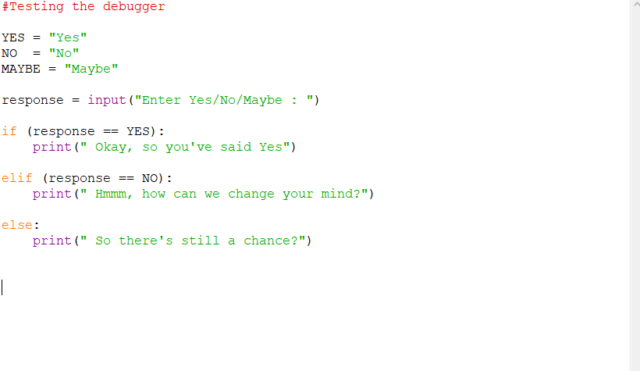
In the example program to the right, there are three branches that the program can follow at run time, due to the if…elif decision.

Note: The example is from the IDLE debugger. Other editors like PyCharm and VSS will have their own version of a debugger, which you will have to learn on your own.

To start the debugger, open up the IDLE and select the Run option, then the Python Shell option.

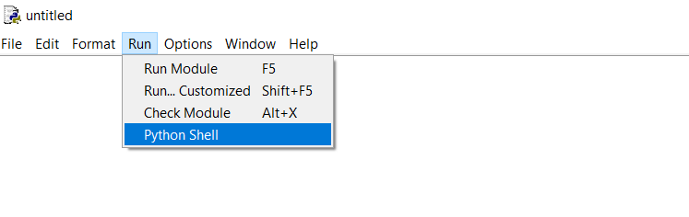

Then, in the Shell, select Debug, then Debugger.

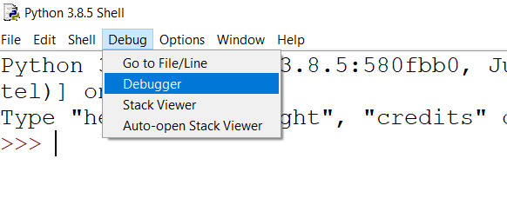
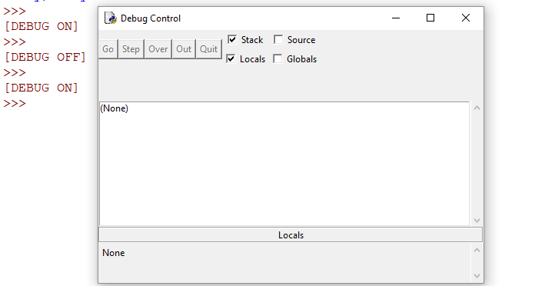
The Debug Control window will appear, and the DEBUG ON statement will show up in the Shell.

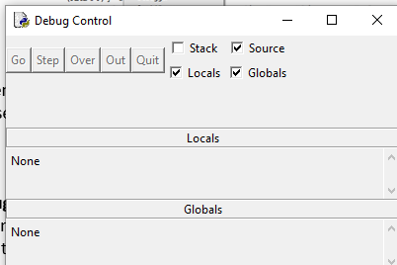
Make the following selections, as seen to the right.

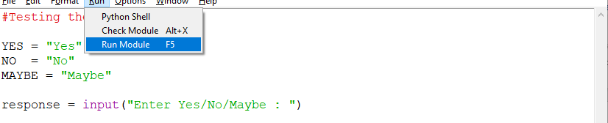

Now go back and start your program.

The Debugger Control will start up, and your source code will get a highlighted line.

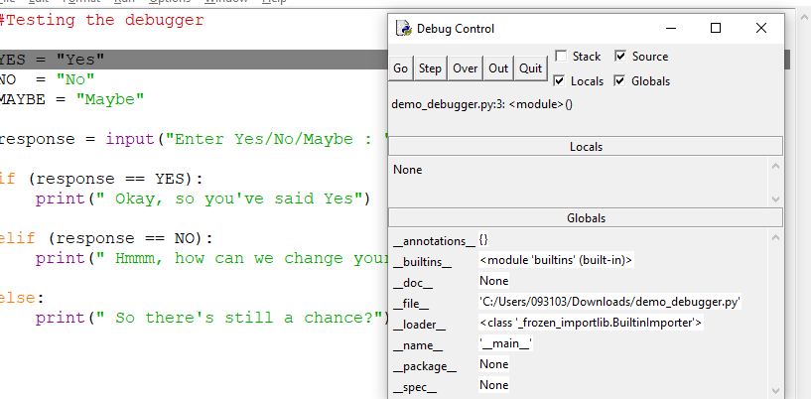
Using the Over button in the Debug Control window, you can execute your program one line at a time.

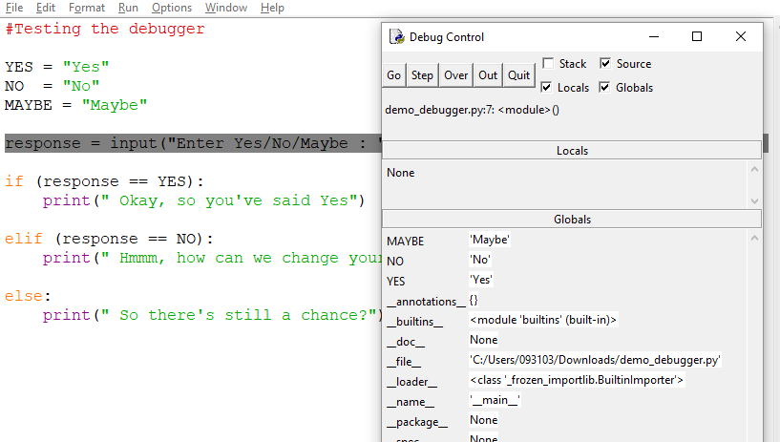

Notice the highlighted line moving as you press “Over”.

The program pauses at input () statements for you to enter data.

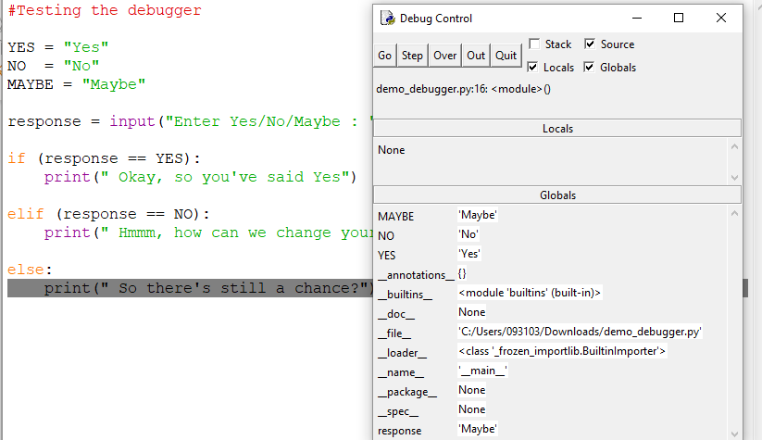
Notice in the Debugger Control variables and their contents show up.

In the source code, you can see the highlighted line shows the branch for Maybe was followed.

IF..ELIF Exercises

Exercise 03.03.01 :
What is printed after the following statements execute? Does the message reflect what was intended? If not, how should the statements be rewritten to produce the intended results?

score = 2

if (score >= 100):
print( “You Won!”)
elif (score < 100):
print (“Good try”)
elif (score < 50):
print (“Practice More”)

Exercise 03.03.02:
Printing prices are typically based on the number of copies to be printed. For example:

Number range | 0 – 499 | 500 – 749 | 750 – 999 | 1000 or more
Price per copy ($) | 0.30 | 0.28 | 0.27 | 0.25

Create a printing_prices program that prompts the user for the number of copies to print and then, when executing, displays the price per copy and the total price, tax not included.
Note: When working with ranged applications, carefully test the boundaries of the ranges, for example, 499 copies, 500 copies and 501 copies.

Exercise 03.03.03:
Create a grades program that allows the user to enter a letter grade (A, B, C, D or E), which then displays the range of marks associated with that letter. Use the following range:
A 80 – 100
B 70 – 79
C 60 – 69
D 50 – 59
E 0 – 49
If the user enters anything else, an error message should appear, for example, “Invalid letter grade”.

Exercise 03.03.04:
Write a program that asks for two input: i) a score between 0 and 100, and ii) the team name of “Eagles”, “Pandas”, or “Cobras”.
Print a message that follows the following:
“Welcome Eagles, and xxxxxxxxxxxxxxxxx”, “Hi Pandas, and xxxxxxxxxxxxxxxxxxx” or “Go Cobras, and xxxxxxxxxxxxxxxxxxxxxx”, depending on the appropriate name entered.
The “xxxxxxxxxxxxxxxxx” part of the message will read as:
“great effort!” if the score is between 0 – 30, inclusive, “solid effort!” if the score is between 31 and 60, inclusive”, “good work!” between 60 and 95, inclusive, and “you are stars!” between 96 to 100, inclusive.

Exercise 03.03.05:
Write a program that can calculate the following geometric properties:

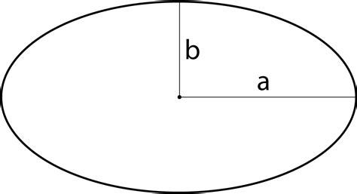
- area of a rectangle given length and width
- area of a circle given the radius
- area of an ellipse given the length of the semi-major axis a, and the semi-minor axis b (see diagram):

First prompt the user for which calculation they want to try.
Then, after the user has selected a calculation, prompt the user for the correct number of measures with appropriate and specific wording.
eg
Which calculation? (1/2/3): 3
Enter the semi-major length : 2.45
Enter the semi-minor length :

